Example:

Sine Ratio

Objective: To understand the sine ratio for angles between 0° to 90°

Key Stage: 3

Learning Unit: Trigonometry

Materials Required: Dynamic geometry software such as Geometer's Sketchpad (later referred as Sketchpad), spreadsheet such as Excel and the file trigo1.gsp

Prerequisite Knowledge: (a) Basic concepts of similar triangles
- Definition of adjacent side, opposite side and hypotenuse for an acute angle of a right-angled triangle

Description of the Activity:
- The teacher recalls the meaning of adjacent side, opposite side and hypotenuse of a right-angled triangle.
- The teacher distributes the worksheet to students. Students are asked to complete the worksheet by using the Sketchpad file trigo1.gsp. In doing the worksheet, students need to investigate the relationship between the opposite side and the hypotenuse for an angle of a right-angled triangle.
- Students make their own conjectures on the relationship after the observation. Afterwards, they should follow the instruction in the worksheet to analyze the relationship of the corresponding data by using Excel.
- The teacher asks students to discuss the reasons of their conjectures.
- The teacher may ask some students to present their conjectures and reasons to the whole class. Students can be guided to use the idea of similarity to prove the invariance nature of the relation.
- The teacher may then introduce the definition of sine ratio and guide students to conclude that:
- the sine ratio is independent of the sizes of the triangles formed;
- the ratio is constant for a fixed angle;
- different angles will give different sine ratios.

Worksheet: Investigation of the relationship between the adjacent
side and the opposite side for an angle of a right angled triangle
Instruction:
- Open the Sketchpad file trigo1.gsp.
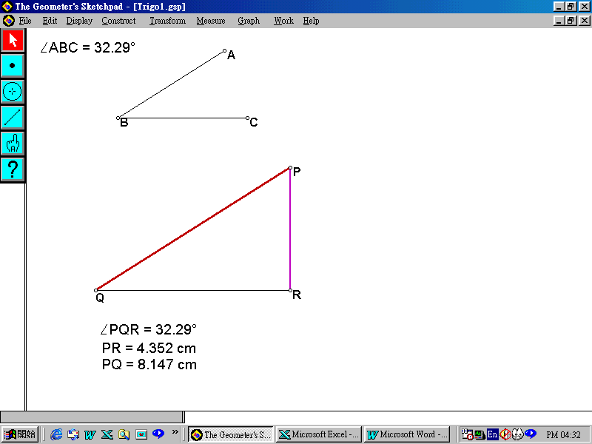
You will find an angle ∠ABC and its measurement on the top of the window. The middle part of the window shows a right-angled triangle with a right angle at R whereas the lower part of the window shows its measurement as shown in Fig. 1. (Please measure the size of ∠PRQ and verify that ΔPQR is actually a right-angled triangle.)
Fig. 1

- Drag the end points of ∠ABC to observe any change that happens in ΔPQR. Write down your finding(s) below.
_________________________________________________________________
_________________________________________________________________
_________________________________________________________________
_________________________________________________________________
- Drag the vertex R of ΔPQR. You will find that the lengths of PR and PQ change simultaneously. Try to use another angle PQR by dragging an end point of ∠ABC. Then drag the vertex R again. Can you guess a relationship between the lengths of PR and PQ for a fixed ∠PQR? Write down your conjecture below.
_________________________________________________________________
_________________________________________________________________
_________________________________________________________________
- Measure ∠PQR, its opposite side PR and its adjacent side PQ and collect the data by using the following steps.
- Hold down the Shift key to highlight the measures of ∠PQR, PR and PQ in the lower part of the window simultaneously.
- Select Measure ⎪ Tabulate in the pull-down menu to create a table.
- Highlight the table formed. Choose Measure ⎪ Flip Direction in the pull-down menu to flip the table.
- Drag the vertex R to another position without changing the size of ∠PQR. Click to select the table and press Ctrl E to add a new record to the table.
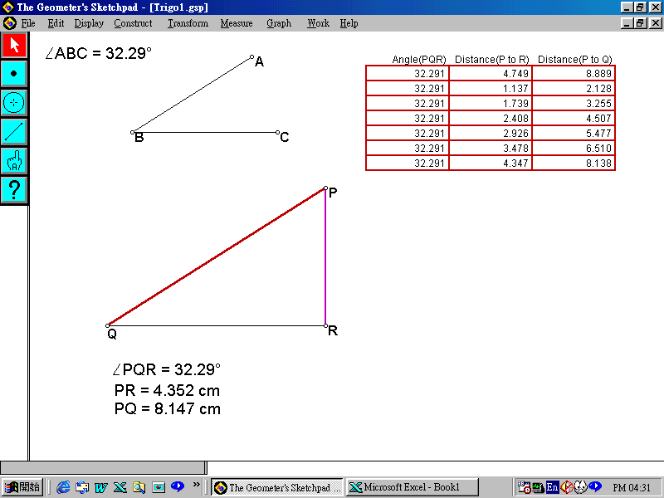
- Repeat the same procedure to add more records (suggested to make up to about 7 records) for this fixed angle to the table as shown in Fig. 2.
Fig. 2

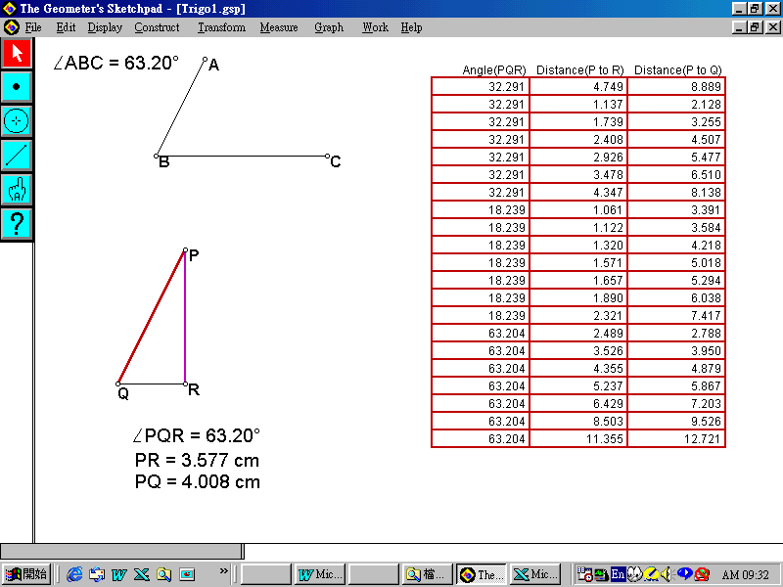
- Drag ∠ABC to change the size of ∠PQR. Repeat steps (d) and (e) to record other sets of data (each set contains about 7 records for the same fixed angle PQR, see Fig. 3).
Fig. 3
- To copy the data into an Excel file in order to analyze the conjecture:
- Highlight the table and press Ctrl C.
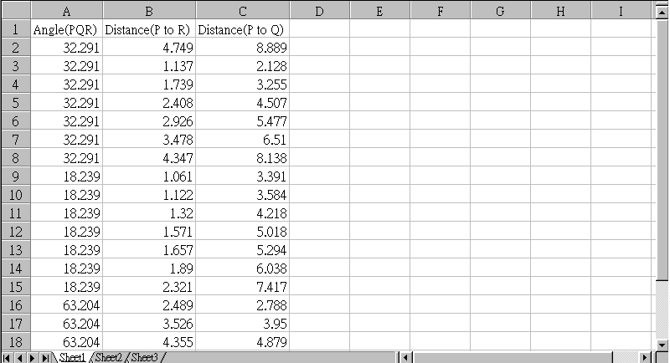
- Open a new Excel file. Click the cell A1 and press Ctrl V to paste the data into the Excel file as shown in Fig. 4.
Fig. 4
- Verify your conjecture in step 3 above by using the Excel file you constructed as shown in Fig. 4.
Is your conjecture correct? _____________
If not, find out a relationship between PR and PQ and write it down below.
(Hint: You may consider PR + PQ, PR − PQ, PR × PQ and PR / PQ)
_________________________________________________________________
_________________________________________________________________
- Discuss with other students for a proof to your conjecture. Write down below.

Notes for Teachers:
- This example aims at introducing the definition of the sine ratio of an acute angle to students. For the sine ratio, students should be able to define it in a right-angled triangle and understand that it is the ratio of the opposite side to the hypotenuse of this angle. Besides, this ratio is independent of the sizes of the triangles formed, as all the corresponding triangles are similar to each other.
- In question 2 of the worksheet, students may find that ∠PQR is always equal to ∠ABC. In question 3, students may find that if PR increases, PQ will also increase. On the other hand, if PR decreases, PQ will also decrease. Instead of asking students to consider , the teacher may ask students to consider the four basic operations for PR and PQ. Students can experience that a new mathematical concept or relationship is usually formed from a lot of data analysis. The inquiring skill as well as reasoning skill can be enhanced through this exemplar.
- The teacher should note that there might be round up error in computing and etc. So students should use sufficient number of data to test their conjectures.
- The teacher can also adopt the idea of this exemplar for the investigation of cosine ratio and tangent ratio of an acute angle.

